***PREVENTITIONS TO AVOID COVID – 19***

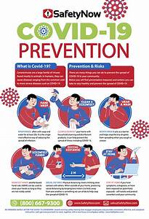

***1. social distancing***

Since close person-to-person contact appears to be the main source of transmission, [**social distancing**](https://healthmatters.nyp.org/what-to-know-about-social-distancing/) remains a key way to mitigate spread. The CDC recommends [**maintaining a distance of approximately 6 feet**](https://www.cdc.gov/coronavirus/2019-ncov/php/public-health-recommendations.html) from others in public places. This distance will help you avoid direct contact with respiratory droplets produced by coughing or sneezing.

***2.Wash your hands***

Wash your hands often with soap and water for at least 20 seconds, especially after you have been in a public place, or after blowing your nose, coughing, or sneezing.

***3. Restrict your travel***

Traveling can increase the spread of COVID-19 and put you at risk for contracting the disease.

***4. Wear a mask***

***5. Avoid crowds and poorly ventilated spaces***

***6. Cover coughs and sneezes***

***7. Clean and disinfect***

***8. Monitor your health daily***